Exclusion/Inclusion

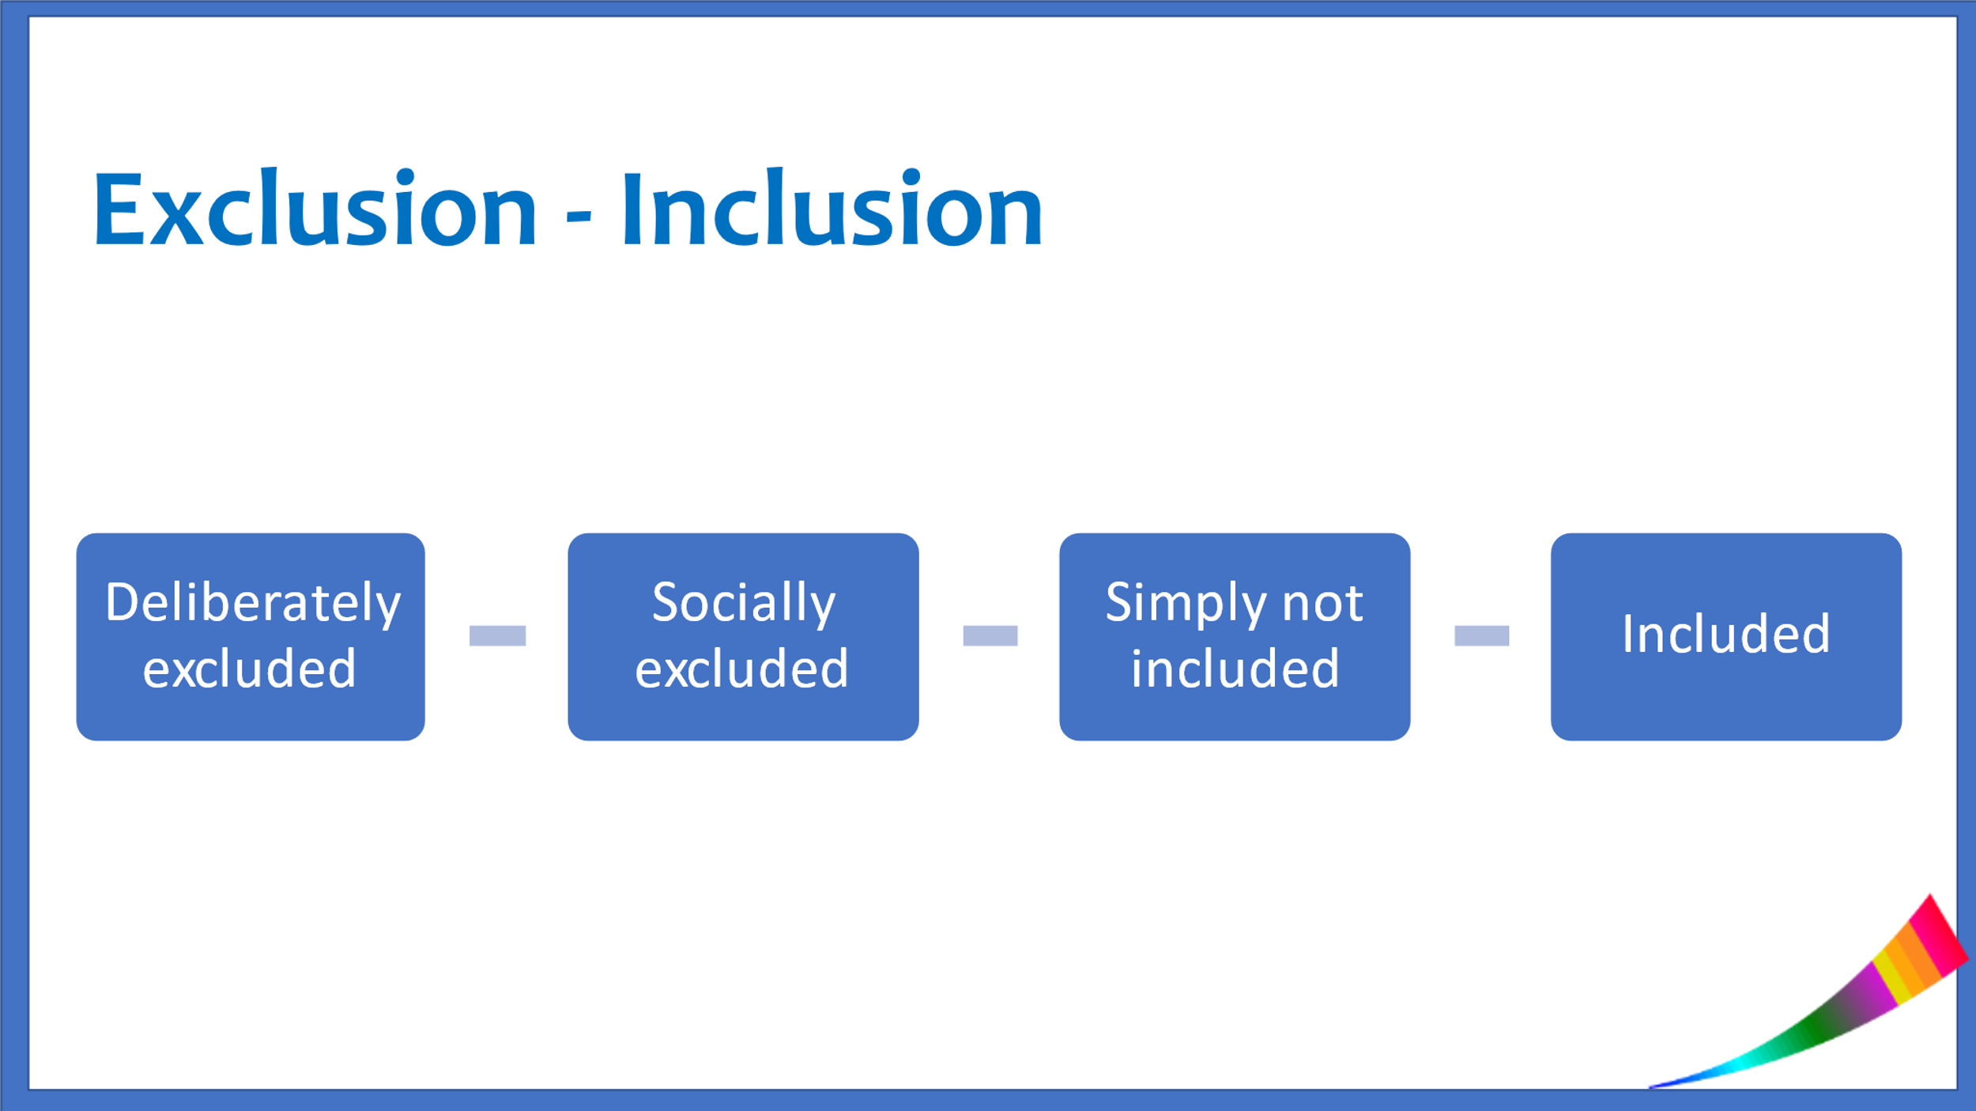

DELIBERATELY EXCLUDED
This might be as a result of both direct and indirect discrimination and can be based on many different characteristics. However, it is only unlawful discrimination under The Equality Act 2010 if you are treated or treat someone unfairly because of any one or more of the so-called ‘protected characteristics’.

The protected characteristics include: disability, gender reassignment, marriage and civil partnership, pregnancy and maternity, race, religion or belief, sex, and sexual orientation.

The discrimination may take the form of being treated less favourably than others because of your characteristic. You may not be offered a job, refused promotion, denied a particular service.

Examples:
A landlord refuses to let you a flat because they think you're gay.
Recently 2 young gay men were refused a house viewing by the owners who were Christians
Refusing an employee time off work for a religious event.
Denying a same-sex couple access to healthcare.
Not allowing an employee access to work opportunities because they are 'too young'.
Not hiring a person because of their disability or not making reasonable adjustments to enable them to do the job

Equality Act guidance - General
www.equalityhumanrights.com/en/advice-and-guidance/equality-act-guidance

What the Equality Act says about sexual orientation discrimination
www.equalityhumanrights.com/en/advice-and-guidance/sexual-orientation-discrimination

What the Equality Act says about the protected characteristics of sex and gender reassignment
www.equalityhumanrights.com/en/advice-and-guidance/what-equality-act-says-about-protected-characteristics-sex-and-gender

It may be less obvious though and this is what we’ve termed ‘social exclusion’.

SOCIALLY EXCLUDED

This covers the ways that people can be excluded in ways that are not necessarily illegal under the Single Equality Act, but may be extremely damaging and have an impact on people’s well being and mental health.

It may be:
- groups or organisations that make it clear it is not OK to be LGBT+ and ‘do not welcome’ people like that! Many religious organisations would likely fall into this category.
- through peer groups, feeling somehow not ok/not ‘normal’/feeling othered – many LGBT+ people’s stories attest to that fact of being scared of feeling different, of not fitting in, living in fear of being ‘outed’
- being forced to leave home because you are disowned by family members – I’d rather my son was dead than gay’ – recent research by the Albert Kennedy Trust flagged up that LGBT young people are disproportionately represented in the young homeless population. As many as 24% of young homeless people are LGBT www.lgbtyouth.org.uk/national-programmes/youth-activism/youth-commission-housing-and-homelessness
- bullying because of being LGBT+ – there is a lot of evidence that LGBT+ young people still experience a high rate of bullying www.the-classroom.org.uk/lgbt-101/homophobic-transphobic-bullying/the-facts
- and the 2018 Government report of the national LGBT+ survey flagged up that at least 2 in 5 respondents (out of a total response rate of 101,000) had experienced some form of harassment or physical violence in the 12 months preceding the research. www.lgbtsand.com/2018/07/03/national-lgbt-survey-summary-report

And, people may FEEL deliberately excluded even when those doing the excluding did not do so deliberately and may just not have thought that there are people who are different from themselves.

NOT INCLUDED

‘It never even occurred to me that there were older LGBT+ people’

This can occur when people have not even thought about LGBT+ people existing. We may look on websites and in organisational literature and not see ourselves. For many of us growing up we didn’t see people like us, maybe didn’t even know anyone like us. We may have also grown up seeing only stereotypes where we were represented – camp gay men and butch lesbians – most of whom got killed off at the end of the story! It may have been that the words ‘lesbian’ or ‘queer’ were used as a slurs in spiteful and disgusted tones – or seen as dirty words – often highly sexualised!

There were likely no role models which meant that it was hard to know how to be in the world. We rarely saw ourselves and our lives reflected in literature, art, culture.

And, of course most of us never imagined that one day we’d be able to legalise our relationships if we choose to do that!

One of the consequences of being ‘invisible’ is that the particular issues impacting on LGBT+ people are not considered and are rarely at the forefront of the minds of policy makers. We are ignored, left out, our needs not considered

LGBT+ people are, of course, as mixed a bunch of individuals as everyone else. We are not asking for special treatment and, in 2022 things are clearly improving. However, we are still not ‘there .

BEING INCLUDED

This what we are aiming for. When we can actually see ourselves as just a part of the furniture! This can have a hugely positive impact on our well-being. It’s when we feel accepted, whatever our differences. It’s about feeling valued, being heard, having equal access to opportunities and resources. It’s when we don’t always have to say… “and have you thought about what that might mean for LGBT+ people…”

It’s when LGBT+ lives are ‘usualised’

The following is taken from Schools Out Learning resources, developed over the years by LGBT+ teachers. www.the-classroom.org.uk. Members of Schools Out initiated February as LGBT History Month www.lgbtplushistorymonth.co.uk and still support national LGBT history events all over the country. The idea is to uncover hidden histories, illustrating and illuminating the often overlooked lives, stories and experiences of LGBT+

So, what does ‘usualising ‘mean? You won’t find this verb in the dictionary. It means to make usual and every day. ‘Normalise’ is its closest synonym.

Why not say ‘normalise’ then? Normalise is problematic when describing humans as it assumes there is a ‘right’ way of being and is therefore a pejorative term to many who consider themselves outside the majority. It also has connotations of ‘trying to fit in’ rather than embracing diversity.

In what context is ‘usualise’ used?
When we usualise something, we acclimatise people to its presence, and take away the threat of difference which creates fear and discrimination.

What does that look like when talking about LGBT+ people?
LGBT+ people are integral to many of our lives. They exist in all times, all places, in the here and now and are part of our society and culture. ‘usualising’ is inclusion through reference, non-comment, non-judgement, non-reaction, acceptance. Usualising LGBT+ lives means we are aware of the diversity of LGBT+ people, and that they share many characteristics with people who are heterosexual. It is also about acknowledging the differences between LGBT individuals themselves, that they do not all conform to the same behaviours/appearance.

The value of Labels.

SAND uses LGBT+ as an umbrella term. What’s important though is to remember that underneath the umbrella are individuals who may or may not identify with or want to use any of those labels.

Labels can be useful – to name how we feel, to find others like us, to be able to articulate what we experience ‘because we are gay or trans’. It can be a way people find their ‘community’ – people who understand them. It can also help to make people feel that their identity is valid.

Some people choose not to adopt any labels – there may be many reasons for that. The important thing is to find out how someone wants to be identified, remembering that humans are messy and complicated and don’t always fit into neat little boxes

